Data Visualization Group Project Report

MIS 6380.002

Visualization of the impact of COVID-19 in Chicago

By Group 10: - Kartik Ahirrao

Pranali Pawar

Kush Sanzgiri

Aishwarya Kobbaji

# Index

|  |  |
| --- | --- |
| Project Description………………………………………………………………………………………………………………………….. | Page 3 |
| Objective…………………………………………………………………………………………………………………………………………. | Page 3 |
| Summary…………………………………………………………………………………………………………………………………………. | Page 4 |
| Data Description……………………………………………………………………………………………………………………………… | Page 5 |
| Data Cleaning………………………………………………………………………………………………………………………………….. | Page 14 |
| Insights & Findings…………………………………………………………………………………………………………………………… | Page 15 |
| Conclusion………………………………………………………………………………………………………………………………………. | Page 21 |

Project Description

This project aims to create a comprehensive visualization of the impact of COVID-19 in Chicago from 2020 to 2023, focusing on the demographic inconsistency in cases, the strain on healthcare infrastructure, and the economic effect on the dining sector. Through data-driven charts, we will highlight how older age groups and different genders have been affected, the correlation between case surges and hospital resource usage, and the pandemic's role in restaurant closures. Our goal is to provide a clear, visual understanding of the pandemic's multifaceted impacts on the city.

# Objective

The project aims to visualize the effects of COVID-19 on Chicago's older residents by presenting data on cases, deaths, and hospitalizations from 2020 to 2023. Additionally, the report will examine gender-based differences in COVID-19 cases in Chicago to explore how men and women were affected differently. It will also depict the relationship between rising COVID-19 cases and the increased use of non-ICU hospital beds to highlight healthcare pressures. The report aims to illustrate the challenge of matching ventilator availability with the needs of COVID-19 patients, showcasing hospital constraints. Furthermore, it will show the impact of COVID-19 on Chicago's restaurants, linking case surges to closures during the same period.

# Summary

Mitigating the long-lasting effects of the COVID-19 pandemic has been a global challenge over the past three years. Nations have emerged stronger from this crisis, partly due to effective vaccine distribution and the resilience of healthcare systems. Our project specifically targets the city of Chicago, aiming to visually analyze the pandemic's profound impact from 2020 to 2023, across various demographic and economic sectors. We plan to use detailed data-driven visualizations to delve into the effects on older residents, gender-based differences in case numbers, the pressures on healthcare infrastructure, and the economic repercussions within the restaurant industry.

Our visualizations will include charts and animations that highlight the critical pressures faced by healthcare providers, such as the use of non-ICU beds and ventilator shortages, alongside the correlation between COVID-19 case surges and restaurant closures. This comprehensive approach aims to not only illustrate the direct impacts but also to explore the broader economic consequences brought on by the pandemic.

Utilizing MS Excel for meticulous data cleansing and Tableau for creating sophisticated graphical presentations, this project intends to provide stakeholders and policymakers with a clearer understanding of these complex issues. By shedding light on the multifaceted effects of the pandemic, we hope to contribute valuable insights that might inform guidelines for managing future health crises, thus enhancing preparedness and response strategies in similar situations.

# Data Description

For this project, we are working with primary data that gives us a complete picture of how COVID-19 impact of COVID-19 in Chicago from 2020 to 2023, focusing on the demographic inconsistency in cases, the strain on healthcare infrastructure, and the economic effect on the dining sector. It's like taking a detailed snapshot that helps us understand the big picture of the impact of COVID-19 across Chicago.

This dataset gives us a thorough summary of everything related to COVID-19's impact on the city of Chicago related to how older age groups and different genders have been affected, the correlation between case surges and hospital resource usage, and the pandemic's role in restaurants.

By incorporating both primary and secondary data, our analysis aims to offer a comprehensive and multi-dimensional understanding of the intricate impact of COVID-19.

|  |  |  |
| --- | --- | --- |
| **Column Name** | **Description** | **Type** |
| Date | Records the date on which the data was collected or reported | Date |
| Cases - Total | The cumulative number of confirmed COVID-19 cases | Number |
| Deaths - Total | The total number of deaths attributed to COVID-19 | Number |
| Hospitalizations - Total | The total number of COVID-19 related hospitalizations | Number |
| Cases - Age 0-17 | The number of COVID-19 cases among different age groups, allowing for age-specific epidemiological analysis | Number |
| Cases - Age 18-29 | The number of COVID-19 cases among different age groups, allowing for age-specific epidemiological analysis | Number |
| Cases - Age 30-39 | The number of COVID-19 cases among different age groups, allowing for age-specific epidemiological analysis | Number |
| Cases - Age 40-49 | The number of COVID-19 cases among different age groups, allowing for age-specific epidemiological analysis | Number |
| Cases - Age 50-59 | The number of COVID-19 cases among different age groups, allowing for age-specific epidemiological analysis | Number |
| Cases - Age 60-69 | The number of COVID-19 cases among different age groups, allowing for age-specific epidemiological analysis | Number |
| Cases - Age 70-79 | The number of COVID-19 cases among different age groups, allowing for age-specific epidemiological analysis | Number |
| Cases - Age 80+ | The number of COVID-19 cases among different age groups, allowing for age-specific epidemiological analysis | Number |
| Cases - Age Unknown | The number of COVID-19 cases among different age groups, allowing for age-specific epidemiological analysis | Number |
| Cases - Female | The distribution of COVID-19 cases by gender | Number |
| Cases - Male | The distribution of COVID-19 cases by gender | Number |
| Cases - Unknown Gender | The distribution of COVID-19 cases by gender | Number |
| Cases - Latinx | The total number of COVID-19 cases within the Latinx community | Number |
| Cases - Asian Non-Latinx | The total number of COVID-19 cases within the Asian community | Number |
| Cases - Black Non-Latinx | The total number of COVID-19 cases within the Black community | Number |
| Cases - White Non-Latinx | The total number of COVID-19 cases within the White community | Number |
| Cases - Other Race Non-Latinx | The count of COVID-19 cases among other non-Latinx races not previously specified | Number |
| Cases - Unknown Race/Ethnicity | COVID-19 cases where race or ethnicity has not been identified | Number |
| Deaths - Age 0-17 | The number of deaths due to COVID-19 across various age groups | Number |
| Deaths - Age 18-29 | The number of deaths due to COVID-19 across various age groups | Number |
| Deaths - Age 30-39 | The number of deaths due to COVID-19 across various age groups | Number |
| Deaths - Age 40-49 | The number of deaths due to COVID-19 across various age groups | Number |
| Deaths - Age 50-59 | The number of deaths due to COVID-19 across various age groups | Number |
| Deaths - Age 60-69 | The number of deaths due to COVID-19 across various age groups | Number |
| Deaths - Age 70-79 | The number of deaths due to COVID-19 across various age groups | Number |
| Deaths - Age 80+ | The number of deaths due to COVID-19 across various age groups | Number |
| Deaths - Age Unknown | The number of deaths due to COVID-19 across various age groups | Number |
| Deaths - Female | The number of COVID-19 related deaths by gender | Number |
| Deaths - Male | The number of COVID-19 related deaths by gender | Number |
| Deaths - Unknown Gender | The number of COVID-19 related deaths by gender | Number |
| Deaths - Latinx | The total number of COVID-19 related deaths within the Latinx population | Number |
| Deaths - Asian Non-Latinx | The number of COVID-19 related deaths in other non-Latinx races | Number |
| Deaths - Black Non-Latinx | The number of COVID-19 related deaths in other non-Latinx races | Number |
| Deaths - White Non-Latinx | The number of COVID-19 related deaths in other non-Latinx races | Number |
| Deaths - Other Race Non-Latinx | The number of COVID-19 related deaths in other non-Latinx races not previously detailed | Number |
| Deaths - Unknown Race/Ethnicity | Deaths due to COVID-19 with unspecified race or ethnicity | Number |
| Hospitalizations - Age 0-17 | The number of COVID-19 related hospitalizations among different age ranges, indicating the severity of cases in each group | Number |
| Hospitalizations - Age 18-29 | The number of COVID-19 related hospitalizations among different age ranges, indicating the severity of cases in each group | Number |
| Hospitalizations - Age 30-39 | The number of COVID-19 related hospitalizations among different age ranges, indicating the severity of cases in each group | Number |
| Hospitalizations - Age 40-49 | The number of COVID-19 related hospitalizations among different age ranges, indicating the severity of cases in each group | Number |
| Hospitalizations - Age 50-59 | The number of COVID-19 related hospitalizations among different age ranges, indicating the severity of cases in each group | Number |
| Hospitalizations - Age 60-69 | The number of COVID-19 related hospitalizations among different age ranges, indicating the severity of cases in each group | Number |
| Hospitalizations - Age 70-79 | The number of COVID-19 related hospitalizations among different age ranges, indicating the severity of cases in each group | Number |
| Hospitalizations - Age 80+ | The number of COVID-19 related hospitalizations among different age ranges, indicating the severity of cases in each group | Number |
| Hospitalizations - Age Unknown | The number of COVID-19 related hospitalizations among different age ranges, indicating the severity of cases in each group | Number |
| Hospitalizations - Female | COVID-19 related hospitalizations categorized by gender | Number |
| Hospitalizations - Male | COVID-19 related hospitalizations categorized by gender | Number |
| Hospitalizations - Unknown Gender | COVID-19 related hospitalizations categorized by gender | Number |
| Hospitalizations - Latinx | The number of hospitalizations due to COVID-19 within the Latinx community | Number |
| Hospitalizations - Asian Non-Latinx | Hospitalizations for specified non-Latinx ethnic groups | Number |
| Hospitalizations - Black Non-Latinx | Hospitalizations for specified non-Latinx ethnic groups | Number |
| Hospitalizations - White Non-Latinx | Hospitalizations for specified non-Latinx ethnic groups | Number |
| Hospitalizations - Other Race Non-Latinx | Hospitalizations for specified non-Latinx ethnic groups | Number |
| Hospitalizations - Unknown Race/Ethnicity | he total hospitalizations for patients whose race or ethnicity is unknown | Number |
| Ventilators - Total Capacity | The total number of ventilators available within the healthcare system | Number |
| Ventilators in Use - Total | The count of all ventilators currently in use, irrespective of the reason | Number |
| Ventilators in Use - COVID-19 | The number of ventilators being used for COVID-19 patients | Number |
| Ventilators in Use - COVID-19 PUI | The number of ventilators used for patients suspected of having COVID-19 but not yet confirmed | Number |
| Ventilators in Use - Non-COVID-19 | Ventilators occupied by patients with conditions other than COVID-19. | Number |
| Ventilators Available - Total | The total number of ventilators currently not in use and available for patients | Number |
| Ventilators Available - Hospital | The number of available ventilators specifically in hospital settings | Number |
| Ventilators Available - EAMC Cache | The number of ventilators available in the Emergency and Acute Medicine Cache, a reserve for emergencies | Number |
| Ventilator Surge Capacity | The additional number of ventilators that can be made available in a surge or peak demand situation | Number |
| ICU Beds - Total Capacity | The total number of ICU beds available | Number |
| ICU Beds - Adult | The division of ICU beds by whether they are for adult use | Number |
| ICU Beds - Pediatric | The division of ICU beds by whether they are for pediatric use | Number |
| ICU Beds in Use - Total | The total number of ICU beds currently occupied | Number |
| ICU Beds in Use - COVID-19 | ICU beds occupied by COVID-19 patients | Number |
| ICU Beds in Use - COVID-19 Patients | May indicate the same as above or be a specific subset | Number |
| ICU Beds in Use - COVID-19 PUI | ICU beds occupied by persons under investigation for COVID-19 | Number |
| ICU Beds in Use - Non-COVID-19 | ICU beds used by patients with conditions other than COVID-19 | Number |
| ICU Beds Available - Total | The number of ICU beds currently unoccupied and available | Number |
| ICU Beds Available - Adult | The number of unoccupied ICU beds available for adults | Number |
| ICU Beds Available - Pediatric | The number of unoccupied ICU beds available for children | Number |
| ICU Beds Surge Capacity - Adult | The additional number of ICU beds that can be provided for adults in a surge situation. | Number |
| ICU Beds Surge Capacity - Pediatric | The additional number of ICU beds that can be provided for children in a surge situation. | Number |
| Acute Non-ICU Beds - Total Capacity | The total number of non-ICU beds designated for acute care | Number |
| Acute Non-ICU Beds in Use - Total | The total number of acute non-ICU beds currently occupied | Number |
| Acute Non-ICU Beds in Use - COVID-19 | Acute non-ICU beds occupied by COVID-19 patients | Number |
| Acute Non-ICU Beds in Use - COVID-19 PUI | Non-ICU acute care beds occupied by potential COVID-19 cases | Number |
| Acute Non-ICU Beds in Use- Non-COVID-19 | The number of acute care beds used by non-COVID-19 patients | Number |
| Acute Non-ICU Beds Available - Total | The total number of unoccupied acute non-ICU beds available | Number |
| Combined Hospital Beds in Use - COVID-19 | The total number of hospital beds (ICU and non-ICU) occupied by COVID-19 patients | Number |
| DBA Name | 'Doing Business As' - The official registered name of the business | Plain Text |
| AKA Name | Also Known As' - Any alternative name the business is known by, which could be used for branding or by customers | Plain Text |
| License # | The unique identifier for the business's operating license | Number |
| Facility Type | Describes the type of establishment, such as a restaurant, café, or bakery | Plain Text |
| Risk | Categorization of the establishment based on the level of health risk its operation may pose to the public | Plain Text |
| Address | The physical street address of the establishment | Plain Text |
| City | The city in which the establishment is located | Plain Text |
| State | The state in which the establishment is located | Plain Text |
| Zip | The ZIP code for the establishment’s location | Number |
| Inspection Date | The date on which a health or safety inspection was conducted | Date |
| Inspection Type | The type or category of the inspection, such as routine or following a complaint | Plain Text |
| Results | The outcome of the inspection, typically indicating whether the establishment passed or failed | Plain Text |
| Violations | Details of any health or safety violations found during the inspection | Plain Text |
| Latitude | The geographical latitude where the establishment is located | Location Cordinates |
| Longitude | The geographical longitude where the establishment is located | Location Cordinates |
| Location | A more detailed or formatted string indicating the geographical location, possibly combining latitude and longitude | Location Cordinates |
| Week Number | The sequential number of the epidemiological week when the data was reported | Number |
| Week Start | The starting date of the reported week. | Date |
| Week End | The ending date of the reported week | Date |
| Cases - Weekly | The number of new COVID-19 cases reported within that week | Number |
| Cases - Cumulative | The total number of COVID-19 cases accumulated up to that week | Number |
| Case Rate - Weekly | The rate of new cases per 100,000 people for that week | Number |
| Case Rate - Cumulative | The cumulative rate of cases per 100,000 people up to that week | Number |
| Tests - Weekly | The number of COVID-19 tests conducted during the week | Number |
| Tests - Cumulative | The total number of COVID-19 tests conducted up to that week | Number |
| Test Rate - Weekly | The rate of tests conducted per 100,000 people during that week | Number |
| Test Rate - Cumulative | The cumulative rate of tests per 100,000 people up to that week | Number |
| Percent Tested Positive - Weekly | The percentage of COVID-19 tests that were positive during that week | Number |
| Percent Tested Positive - Cumulative | The cumulative percentage of positive COVID-19 tests up to that week | Number |
| Deaths - Weekly | The number of deaths attributed to COVID-19 reported in that week | Number |
| Deaths - Cumulative | The total number of deaths attributed to COVID-19 up to that week | Number |
| Death Rate - Weekly | The rate of deaths per 100,000 people for that week | Number |
| Death Rate - Cumulative | The cumulative death rate per 100,000 people up to that week | Number |
| Population | The total population of the ZIP code area | Number |

# Data Cleaning

In the initial phase of our project, we utilized MS Excel as a data cleansing tool owing to its efficiency in handling tasks such as sorting, filtering, and applying conditional formatting. Its user-friendly interface and versatile data transformation capabilities make it a preferred choice for detecting and rectifying missing data. Additionally, Excel facilitates editing and filtering of data as necessary, facilitating the creation of visualizations. Fortunately, the data was found to be inherently clean and free from any inconsistencies or errors. As a result, no specific data-cleaning procedures were required. Given the substantial volume of data, importing it directly into Tableau was deemed the most efficient approach. This decision was motivated by the data's cumulative nature over the period of three years and well-maintained nature, making it suitable for direct integration without the need for intermediary cleaning processes.

# Insights and findings

## Hypothesis 1

### Older age groups (50+) are less likely to have higher total cases, deaths, and hospitalizations compared to younger age groups (<50), potentially due to more cautious behaviors, such as social distancing and vaccination, adopted by the older population.

The interplay between age, behavior, and the impact of COVID-19 has been a subject of considerable interest in our research. We initially hypothesized that older age groups (50+) would exhibit lower total cases, deaths, and hospitalizations compared to the younger demographic (under 50), based on the presumption that the older population may adhere more strictly to preventive measures like social distancing and vaccination.

To explore this hypothesis, we analyzed data trends and developed visualizations focusing on the affected age brackets. Despite our anticipations, the analysis unfolded a different narrative: individuals aged 50 and over reported nearly triple the number of cases than those under 50.

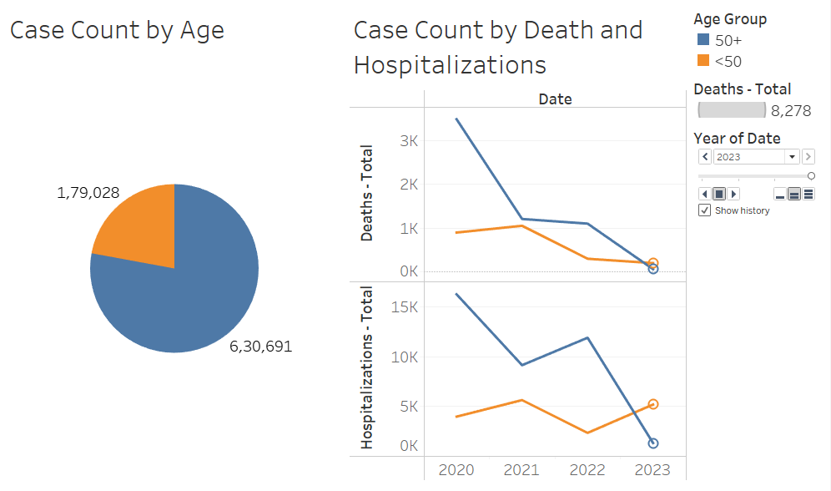

A deeper dive into the year 2023 showed a promising trend—a significant decline in deaths despite a rise in hospitalizations, suggesting a positive impact of vaccination efforts and advancements in hospital care. Nevertheless, the data indicated that the age group under 50 experienced fewer deaths and hospitalizations, while those 50 and over encountered more severe outcomes, leading to a greater number of hospitalizations and deaths.

In conclusion, our hypothesis was not supported by the observed data. The older population suffered greater hospitalizations and fatalities compared to their younger counterparts. However, there is a silver lining as the data from 2023 reflects. With the progress in healthcare responses and increased vaccination rates, the mortality among the older population began to wane.

This outcome highlights a critical aspect of public health policy—while the older age group faced a disproportionate burden, the escalation in healthcare provision and vaccination campaigns have borne fruit, showcasing a decrease in death rates. These insights are invaluable for shaping future strategies, accentuating the need for sustained efforts to protect the most vulnerable and bolstering the fight against the pandemic with a ray of hope for the older demographic.

## Hypothesis 2

### There is a correlation between the total number of COVID-19 cases and the utilization of acute non-ICU beds for COVID-19 patients, reflecting the overall burden on hospital resources, due to the increased demand for medical care as case numbers rise

During the relentless battle against COVID-19, a critical concern for healthcare systems has been the correlation between rising case numbers and the use of acute non-ICU beds. We hypothesized that as COVID-19 cases increase, there would be a concurrent rise in the utilization of these beds, signaling a direct burden on hospital resources.

To test our hypothesis, we closely monitored the trends from 2021 through 2023, expecting to find an increase in the use of non-ICU beds in line with the rise in case numbers. We meticulously gathered data, analyzed it, and created visualizations to elucidate the relationship between case surges and bed usage.

Contrary to our expectations, the data presented a different scenario. Despite a significant increase in COVID-19 cases from 2021 to 2022, we observed no corresponding increase in the utilization of non-ICU beds. The usage rates remained relatively stable into 2022, and then a sharp decrease was noted in 2023.

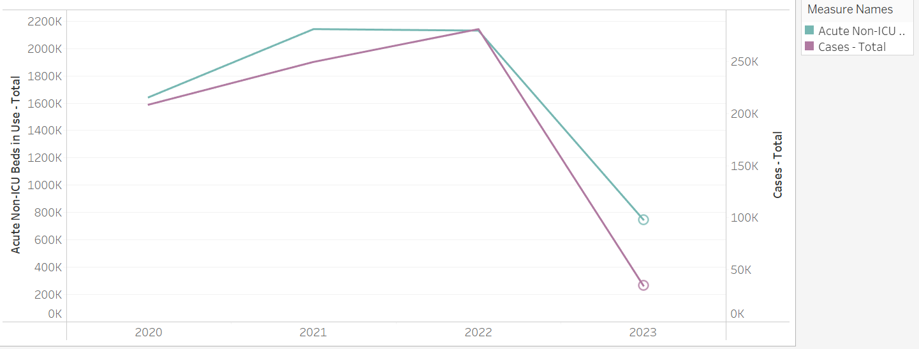

In conclusion, our hypothesis did not stand the test of empirical scrutiny. The anticipated higher demand for non-ICU beds correlating with increased cases did not manifest in the data. This could imply that while more individuals were contracting the virus, the severity of the cases might not have necessitated hospitalization, or that healthcare practices evolved to manage more patients outside of the hospital setting.

This finding compels us to reconsider our understanding of hospital resource allocation during the pandemic. It suggests that factors other than total case numbers may play a more critical role in influencing hospital bed usage, such as improvements in treatment protocols, increased availability of outpatient care, and perhaps the implementation of early intervention strategies that prevented severe illness progression. This insight can inform healthcare strategies and resource planning for ongoing and future public health crises, ensuring that hospital capacity is optimized for those in need.

## Hypothesis 3

### The availability of ventilators is inversely correlated with the number of COVID-19 patients requiring ventilator support, indicating that as more patients require ventilatory assistance, fewer ventilators are available, highlighting the strain on critical care resources during peak demand periods.

In the landscape of the COVID-19 pandemic, the management of healthcare resources, especially ventilators, has been of paramount importance. Our hypothesis focused on the dynamics of ventilator availability: We proposed an inverse relationship between the availability of ventilators and the number of COVID-19 patients requiring ventilatory support. Our expectation was that as the number of patients in need of ventilators climbed, the number of available ventilators would correspondingly decrease, thereby intensifying the strain on critical care resources during peak periods.

To evaluate this, we meticulously collected data across periods of fluctuating patient needs. The analysis intended to showcase this relationship through a carefully designed visualization that plotted ventilator availability against the demand for ventilatory assistance.

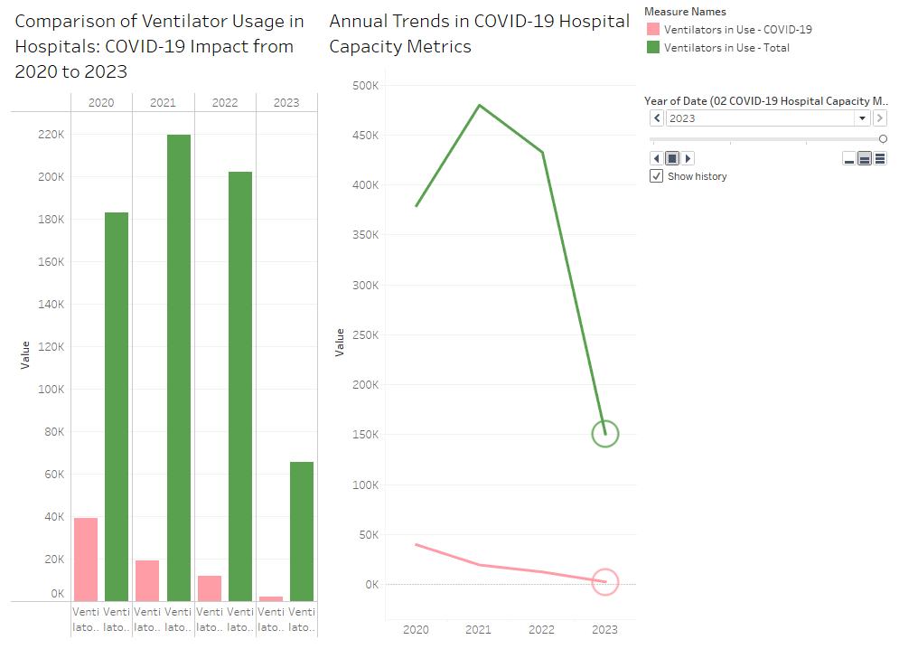

Contrary to our initial assumptions, our findings painted a different picture. The data revealed that as the demand for ventilators rose, the availability of these critical units also increased. This counterintuitive trend was accompanied by an overall decrease in ventilator usage, suggesting the impact of other intervening variables, such as the effectiveness of vaccination campaigns, advancements in COVID-19 treatments, or a possible reduction in virus transmission rates.

Conclusion: The initial hypothesis was not upheld by the data. Rather than a shortage, the healthcare system demonstrated adaptability and resilience by increasing ventilator availability in response to rising demands. This observation may reflect successful public health interventions, such as widespread vaccinations reducing severe disease incidence, effective treatments minimizing the progression to critical illness, and perhaps a general decrease in case numbers due to containment measures.

These observations point towards an improvement in the management of COVID-19, particularly in the critical care domain, suggesting that our healthcare systems have grown more adept at navigating the challenges presented by the pandemic, resulting in a reduced strain on essential resources like ventilators. This bodes well for the future management of the pandemic, indicating readiness and capacity to meet the critical needs of patients even as we face surges in cases.

## Hypothesis 4

### There is a relationship between COVID-19 case rates and restaurant closures, suggesting that higher infection rates may lead to more frequent or extensive closures as a public health measure to mitigate the virus's spread.

In the throes of the COVID-19 pandemic, public health measures often necessitated the closure of various establishments, with restaurants facing significant scrutiny due to their nature as social gathering spaces. We hypothesized that an escalation in COVID-19 case rates would correlate with an increase in restaurant closures, serving as a reactive public health measure to curtail the spread of the virus.

To examine the validity of this hypothesis, we analyzed data over a three-year period to investigate the interplay between COVID-19 case rates and the frequency and extent of restaurant closures in Chicago. We anticipated finding a direct correlation: as infection rates climbed, so too would the number of restaurants shuttering their doors, whether temporarily or permanently.

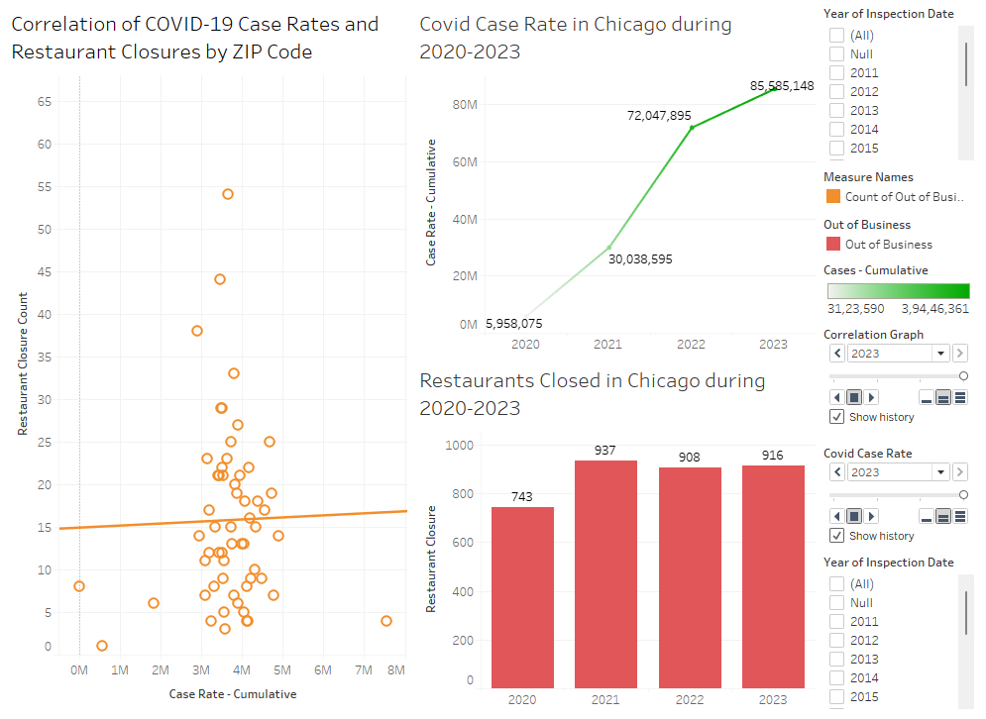

However, the findings challenged our expectations. Despite a dramatic surge in COVID-19 cases in Chicago over the analyzed period, the data did not show a corresponding increase in restaurant closures. The closures exhibited only a slight uptick, defying the anticipated trend. Furthermore, statistical analysis revealed a p-value greater than 0.05, diminishing the strength of any asserted relationship between COVID-19 case rates and restaurant closures within a 95% confidence interval.

Conclusion: Our hypothesis did not hold. The anticipated consistent link between rising infection rates and restaurant closures was not substantiated by the data. This suggests that higher case rates did not systematically result in an increase in restaurant closures across the city during the period analyzed. This finding invites a nuanced understanding of the factors influencing public health decisions regarding closures, indicating that variables beyond case rates may significantly impact such measures. It points to a complex decision-making landscape where public health strategies may also consider economic implications, the mental well-being of the community, or the capacity of healthcare systems to manage cases without resorting to widespread closures.

## Hypothesis 5

### Restaurants located in areas with high COVID-19 transmission rates were more likely to face closures due to government-imposed restrictions and reduced customer demand, reflecting the direct impact of pandemic severity on local business operations.

As the COVID-19 pandemic unfolded, it cast a long shadow over local economies, particularly the restaurant industry. We hypothesized that restaurants situated in areas with higher COVID-19 transmission rates would experience more frequent closures, attributing this to both government-imposed restrictions and a dip in consumer demand – a reflection of the pandemic's severity directly influencing local business operations.

Our analysis targeted the correlation between transmission rates and restaurant closures, with a particular focus on those designated as high-risk areas. We anticipated that as cases mounted, these high-risk zones would see a rise in restaurant closures due to heightened public health measures and reduced patronage.

However, our findings deviated from our hypothesis. Despite a marked increase in average COVID-19 cases in high-risk areas, data from 2022 and 2023 revealed a counterintuitive trend: there were ironically fewer restaurant closures, which suggests a level of adaptation to living with COVID-19.

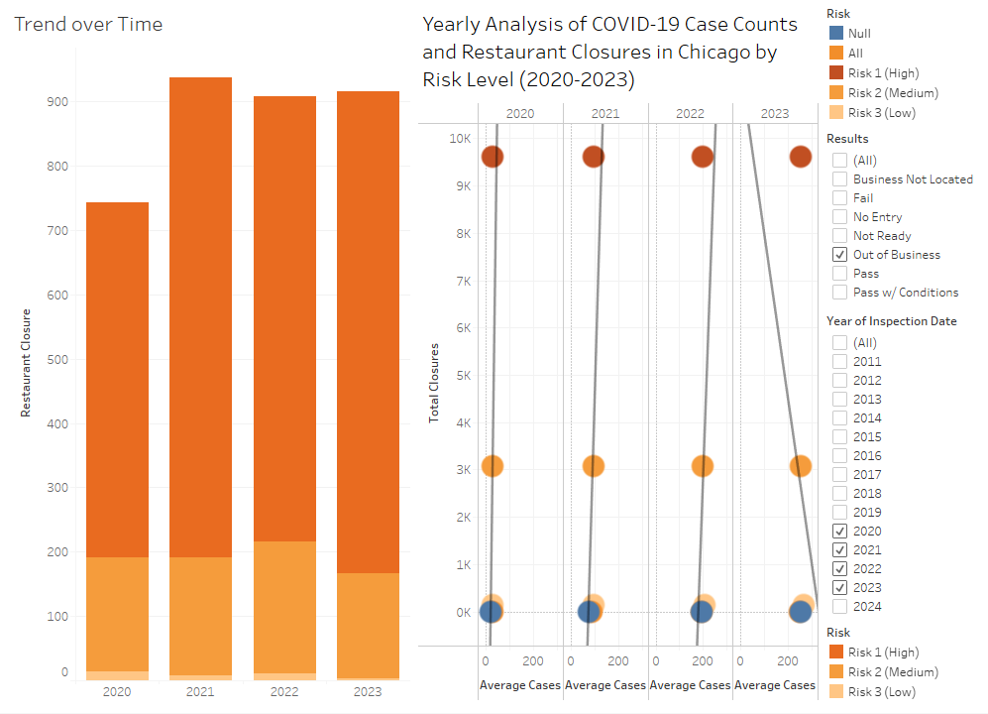  
Conclusion: The hypothesis did not find support in the observed data trends. Rather than an increase in closures in response to rising cases, we discovered that fewer restaurants closed down during the years 2022 and 2023, despite an uptick in case counts. This unexpected outcome implies a resilience within the restaurant industry, pointing to adaptive strategies that allowed for continued operation amidst the pandemic. Whether through enhanced safety protocols, adaptation to delivery and takeout models, or increased public tolerance for risk, the restaurant sector demonstrated a capacity to withstand the pressures of the pandemic without resorting to widescale closures. This resilience not only highlights the industry's agility but also underlines a broader societal shift towards finding a sustainable balance between public health and economic activity.

# Conclusion

In our examination of COVID-19's impact, we discovered that despite higher infection rates, older adults faced more severe outcomes, which improved with increased vaccinations and better care by 2023. Surprisingly, the rise in cases didn't lead to higher utilization of non-ICU beds or ventilators, suggesting improved management and treatment efficiency. The expected correlation between case rates and restaurant closures was not evident; instead, the data showed resilience in the restaurant industry with fewer closures, indicating adaptation to the pandemic. Across these varied findings, the need for adaptable public health strategies and the importance of collaboration among policymakers, healthcare systems, and communities became clear. Our research underscores the complexity of pandemic response and the ability of systems to adapt and withstand the challenges presented by such public health crises.